To improve this code, I used PMD, SonarLint, and Sloc. Results before improving:

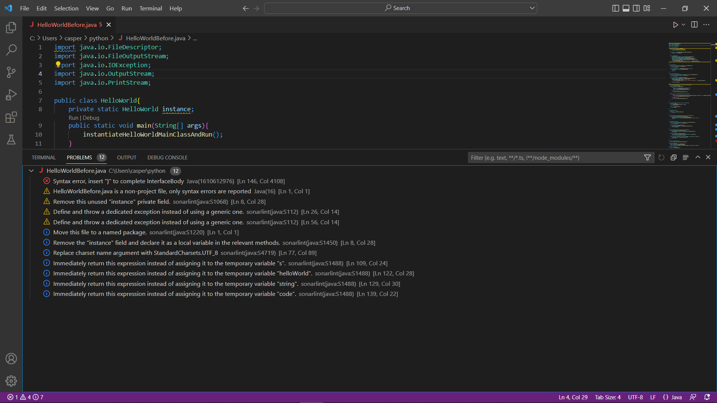

I first solved the syntax error so the code can run properly.

I made the code simpler by removing unnecessary variables and directly returning values.

I removed unnecessary modifiers.

I removed unused private fields.

I removed unused imports.

Here are the results after improving the code:



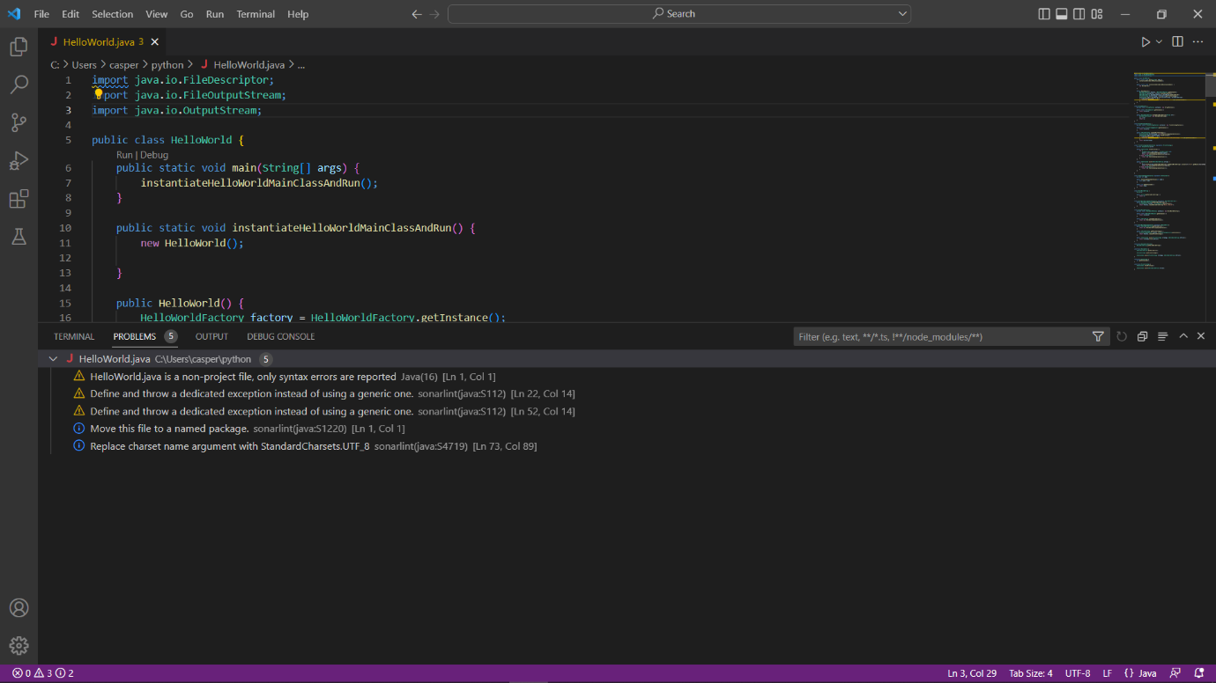

As you can see most of the problems found by PMD and SonarLint are now gone.

The code is also easier to read to after removing unnecessary variables and returning values directly.